Target type IP mode:-
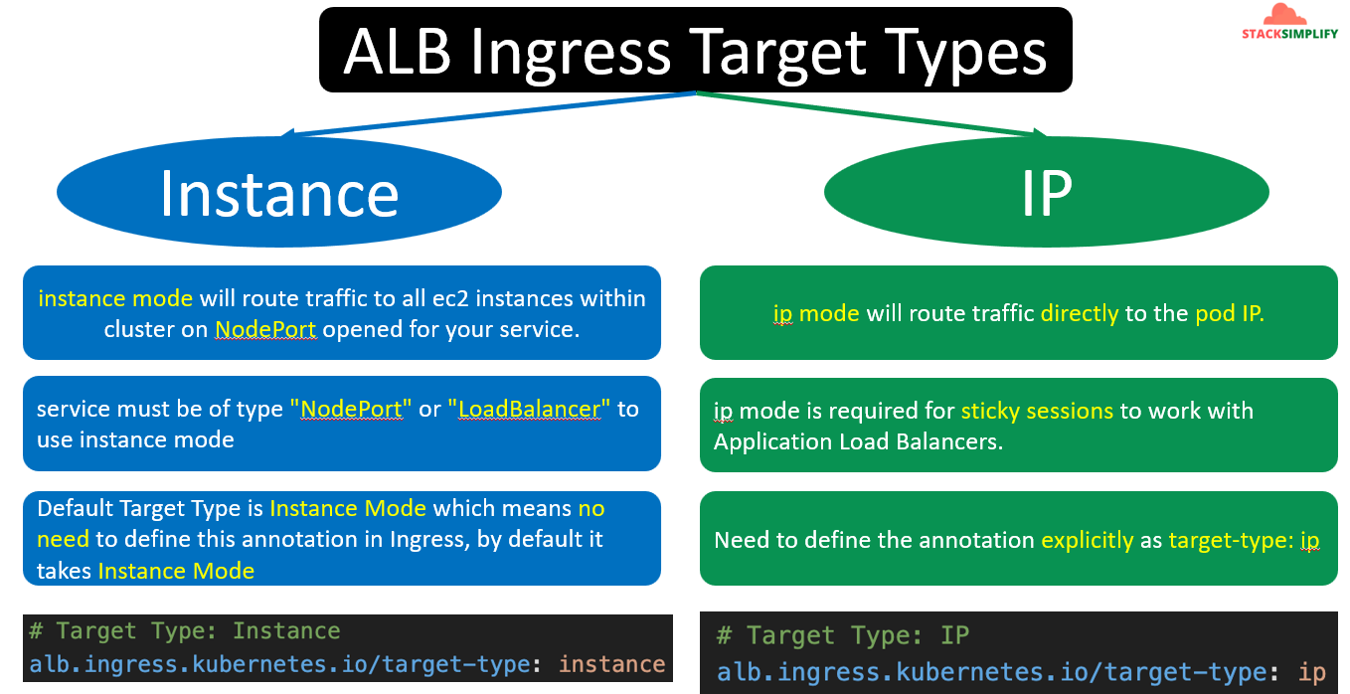
We need make below changes in the ingress manifest.
And we are using ssl discovery.

For each app manifest we have defined the service as clusterIP
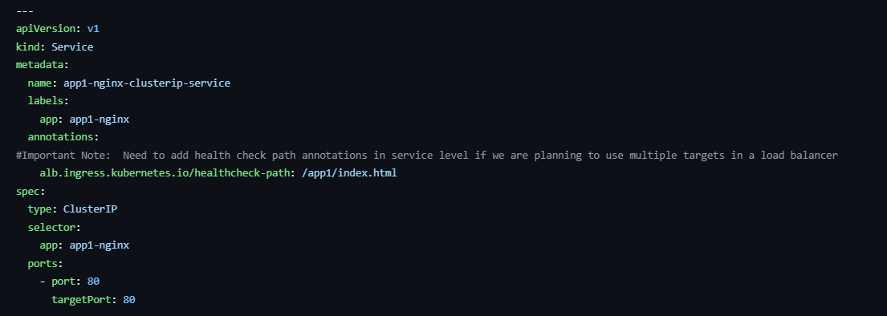
Usually it’s not required to define the clusterip service separately. But, If we want to add our health check paths to our target group then we need to mention service name. For Target type IP we can use both service as ClusterIP or nodePort. In the Fargate session we will be using the NodePort.
Note:- The POD IPs will be directly registered to the target groups.

